Prize:
Won 2ND prize in “PAPER PRESENTATION” event of “POLYSYM’-24(A State Level Technical Symposium)” conducted by NACHIMUTHU POLYTECHNIC COLLEGE on 31.01.2024
Won 1ST prize in “MATH QUIZ” event of “VEDIC MATHEMATICS” conducted by SRI RAMAKRISHNA ENGINEERING COLLEGE on 23.09.2023
Won 1ST prize in “PAPER PRESENTATION” of “RAMANUJAN’S LIFE AND WORK(IE)” conducted by SRI RAMAKRISHNA POLYTECHNIC COLLEGE on 18.12.2023
Won 1ST prize in “QUIZ” of “RAMANUJAN’S LIFE AND WORK(IE)” conducted by SRI RAMAKRISHNA POLYTECHNIC College on 20.12.2023
Won 3ND prize in “PAPER PRESENTATION” event of “INFINITUM’-24(A State Level Technical Symposium)”” conducted by CIT SANDWICH POLYTECHNIC COLLEGE on 01.03.2024
Won 1ST prize in “CODE DEBUGGING” conducted by SRI RAMAKRISHNA POLYTECHNIC COLLEGE on 23.07.2024
Won 1ST prize in “CODE BUSTERS” conducted by KGiSL INSTITUTE OF TECHNOLOGY(A National Level Technical Symposium) on 17.04.2025
Participations
Participated in CODEXTREME event of “NEXUS’ 23 (A National Level Technical Symposium)” conducted by KGiSL INSTITUTE OF TECHNOLOGY on 05.10.2023
Participated in “PAPER PRESENTATION” event of “POLYSYM’-24(A State Level Technical Symposium)” conducted by NACHIMUTHU POLYTECHNIC COLLEGE on 31.01.2024
Participated in “PAPER PRESENTATION” event conducted by SRI RAMAKRISHNA ENGINEERING COLLEGE on 22.02.2024
Participated in “CLUMINATI” event of “INFINITUM’-24(A State Level Technical Symposium)”” conducted by CIT SANDWICH POLYTECHNIC COLLEGE on 01.03.2024
Participated in “QUIZ” event of “TANSACS(A State Level Online Quiz Competition)” conducted by TAMIL NADU STATE AIDS CONTROL SOCIETY(RRC) on 12.08.2024
Participated in “QUIZ” event of “NATIONAL LEVEL SRINIVASA RAMANUJAN MATHEMATICAL COMPETITION 2024” conducted by ISTE on 20.10.2024
Participated in “PAPER PRESENTATION” event of “PA TECHARENA 2K25(A State Level Technical Symposium)” conducted by P.A.POLYTECHNIC COLLEGE on 07.02.2025
Participated in“PAPER PRESENTATION” event of “POLYSYM”2025(A State Level Technical Symposium)” conducted by NACHIMUTHU POLYTECHNIC COLLEGE on 19.02.2025
Participated in “PROJECT PRESENTATION” event of “MINI MINDS,MEGA IDEAS” conducted by SRI RAMAKRISHNA POLYTECHNIC COLLEGE on 15.09.2025
Participated in “ONLINE QUIZ” event of “VBYLD(2026)” conducted by MYBharat( Ministry Of Youth Affairs and Sports of India,) on 14.10.2025
MOOCS
Successfully completed a Skill development course in “Basics of Python” conducted by infosys springboard on 12.07.2023
Successfully completed a Skill development course in “Interactive Skills” conducted by infosys springboard on 17.07.2023
Successfully completed a Skill development course in “Bussiness English” conducted by infosys springboard on 24.07.2023
Successfully completed a Skill development course in “Email Writing Skills” conducted by infosys springboard on 24.07.2023
Successfully completed a Skill development course in “Design Thinking” conducted by infosys springboard on 08.08.2023
Successfully completed a Skill development course in “AI For India 2,0” conducted by GUVI through skill india digital on 17.08.2023
Successfully completed a Skill development course in “Introduction to Digital Marketing” conducted by INFOSYS SPRINGBOARD on 18.01.2024
Successfully completed a Skill development course in “Java Tools” conducted by infosys springboard on 26.03.2024
Successfully completed a Skill development course in “Experiment-Smoke Detector[Centrado kit]” conducted by Infosys Springboard on 09.09.2024
Successfully completed a Skill development course in “Job Application Essentials” conducted by IBM SkillsBuild on 21.09.2024
Successfully completed a Skill development course in “Working in a Digital World:Professional Skills” conducted by IBM SkillsBuild on 21.09.2024
Successfully completed a Skill development course in “TNSDC-Employability Skills” conducted by IBM SkillsBuild on 21.09.2024
Successfully completed a Skill development course in “Mobile App Development” conducted by PANTECH and Naan Mudhalvan on 28.11.2025
Successfully completed a Professional Course in “Planning Efficient Meetings” conducted via Udemy on 21 December 2025.
Successfully completed a Professional Course in “Project Kickoff Meetings: How to Lead Them Effectively” conducted via Udemy on 21 December 2025.
Successfully completed a Professional Course in “Presentation Skills: The Complete Guide” conducted via Udemy on 21 December 2025.
Successfully completed a Professional Course in “Oracle Database Utilities – Perform Data Export / Import” conducted via Udemy on 21 December 2025.
Successfully completed a Skill Development Course in “Configuring Tomcat & PHP” conducted by Infosys Springboard on 20 December 2025.
Successfully completed a Skill Development Course in “OWASP Top 10: Protecting Against Threats and Vulnerabilities” conducted by Infosys Springboard on 20 December 2025.
Successfully completed a Professional Certification Course in “Microsoft 365 Certified: Fundamentals (MS-900)” conducted via Udemy on 21 December 2025.
Successfully completed a Skill Development Course in “Observability in Cloud Native Apps Using OpenTelemetry” conducted by Infosys Springboard on 20 December 2025.
Successfully completed a Skill Development Course in “GenAI for IT: Transforming IT with Generative AI” conducted by Infosys Springboard on 20 December 2025.
Successfully completed a Skill Development Course in “II PU Computer Science” conducted by Infosys Springboard on 21 December 2025.
Successfully completed a Skill Development Course in “ChatGPT for Everyone” conducted by GUVI on 20 December 2025.
Successfully completed a Professional Course in “GenAI for Professionals: 10x Your Productivity” conducted via Udemy on 20 December 2025.
Successfully completed a Professional Course in “OWASP Top 10: Protecting Against Threats and Vulnerabilities” conducted via Udemy on 20 December 2025.
Successfully completed a Professional Course in “Observability in Cloud Native Apps Using OpenTelemetry” conducted via Udemy on 20 December 2025.
Successfully completed a Professional Course in “Python Basics Course” conducted via Udemy on 21 December 2025.
Successfully completed a Professional Course in “Performance Testing Course with JMeter and Blazemeter” conducted via Udemy on 21 December 2025.

Workshop
Participated in Workshop on “Awareness Session on Exploration of AR/VR” conducted by SRI RAMAKRISHNA POLYTECHNIC COLLEGE on 13.10.2023.
Successfully completed “PC and Laptop Trouble Shooting,Networking” conducted by by SRI RAMAKRISHNA POLYTECHNIC COLLEGE on 20.O5.2024 to 24.05.2024(5days)

Skill development program
Successfully completed “23MACCEO1–VEDIC MATHEMATICS” conducted by SRI RAMAKRISHNA ENGINEERING COLLEGE on 22.O9.2023 to 23.09.2023
Internship
Successfully completed an internship on “AI-Powered Integrated System Design: A Hands-on Approach with Soft Tools ” conducted by SRI RAMAKRISHNA ENGINEERING COLLEGE on 20.01.25 to 25.01.25(50hrs)

Prize:
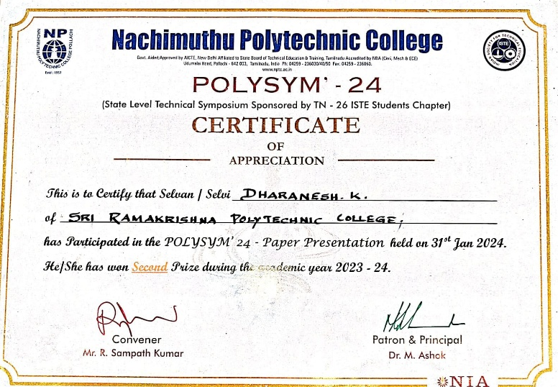 | 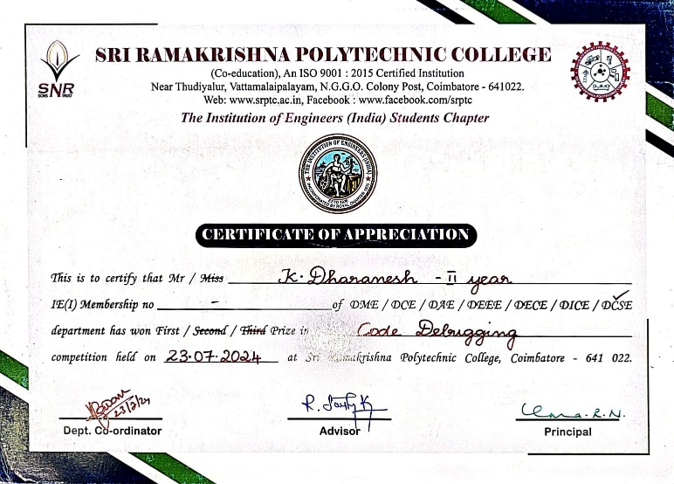
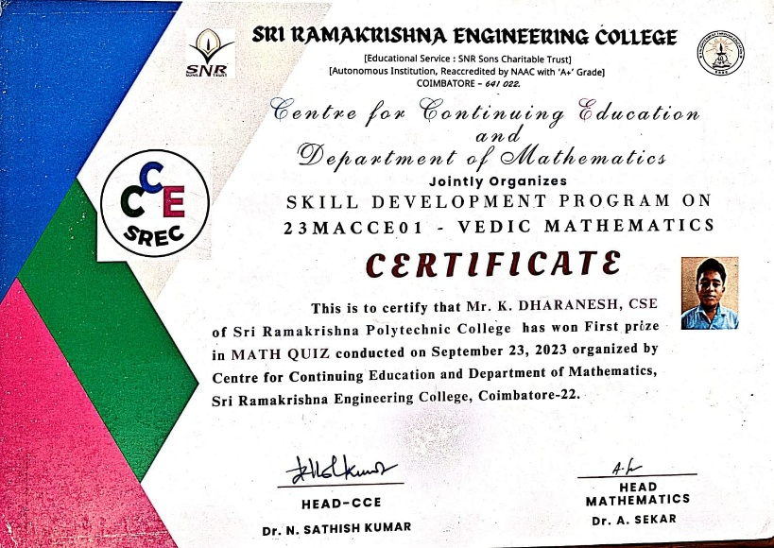 | 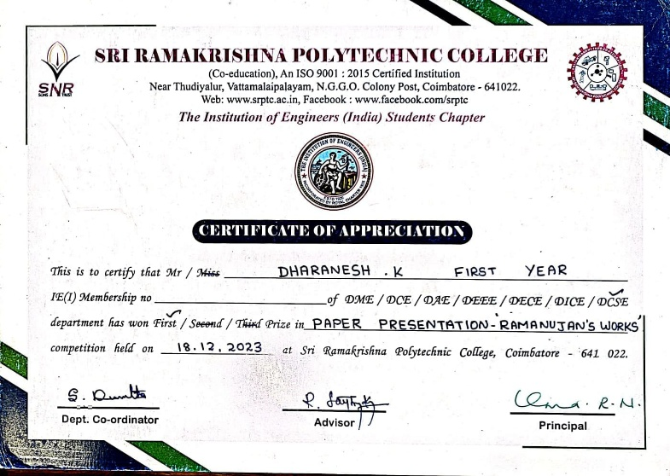
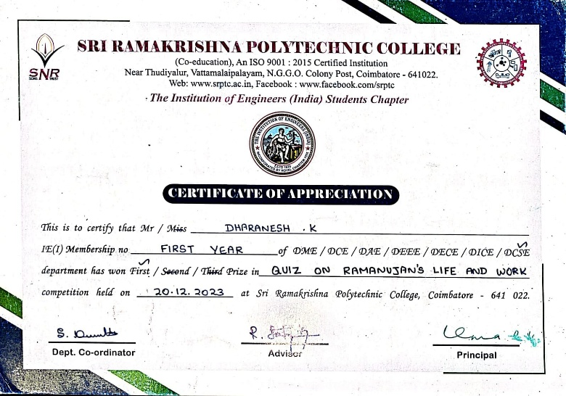 | 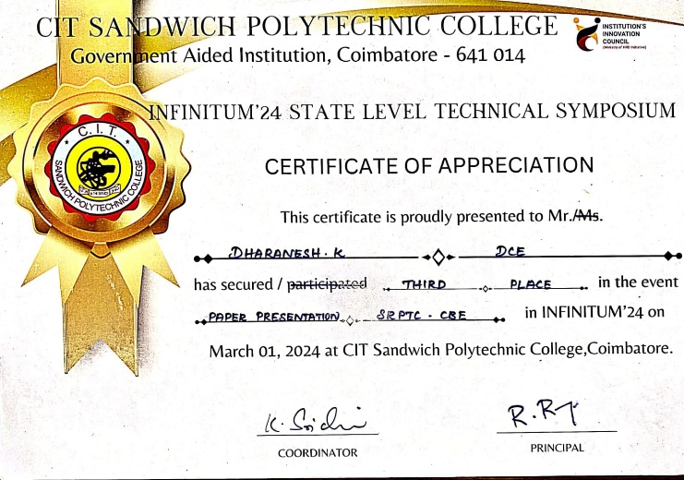

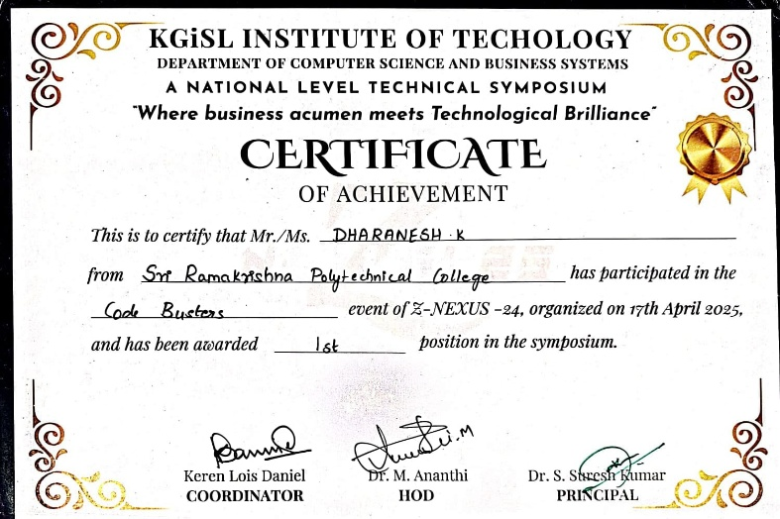

Participations
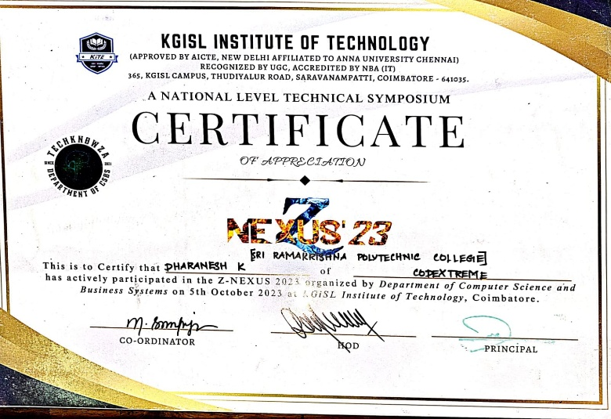 | 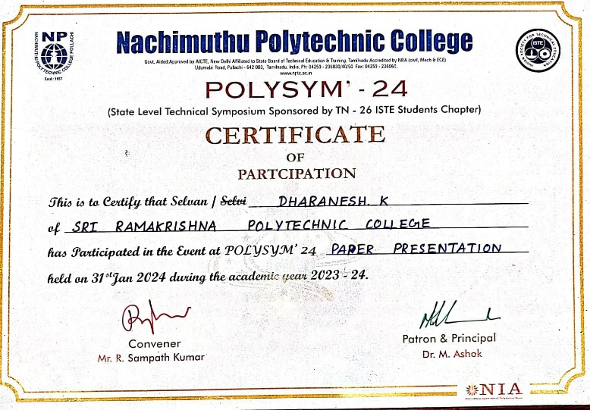
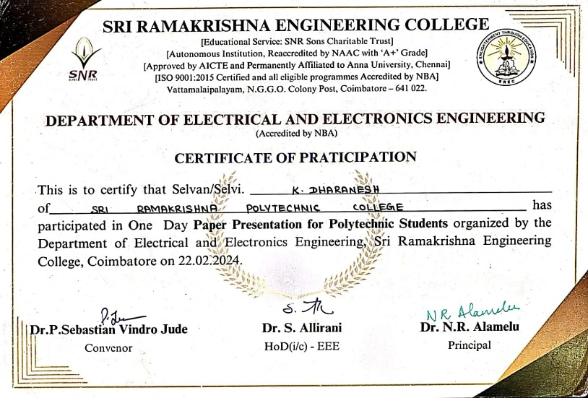 | 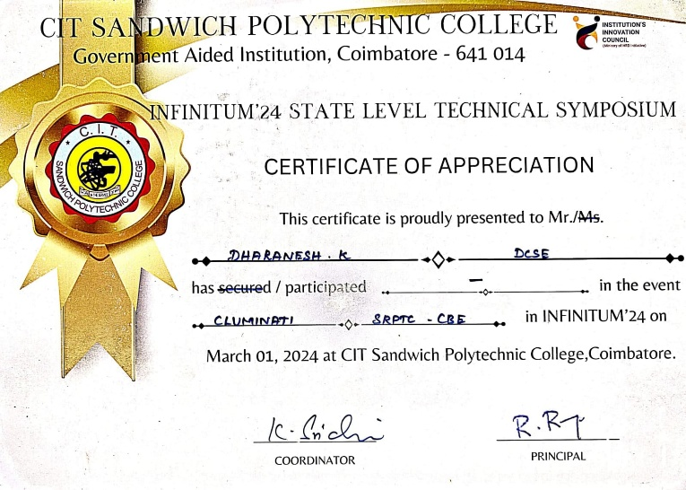

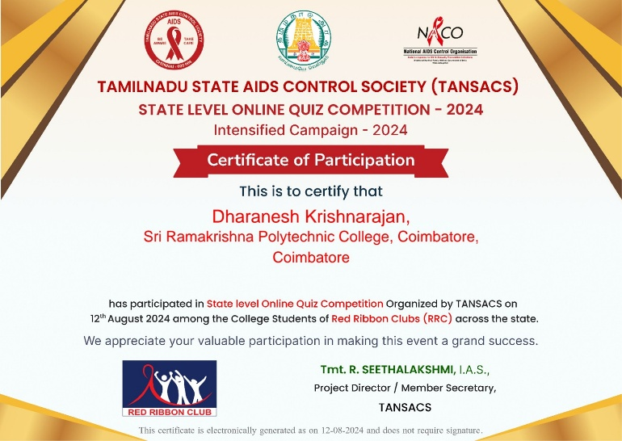 | 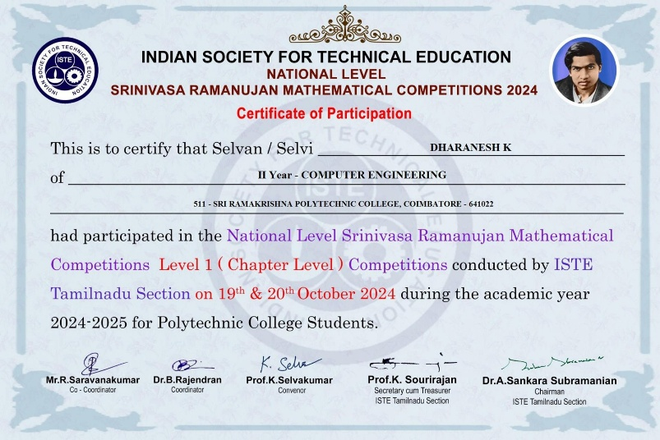
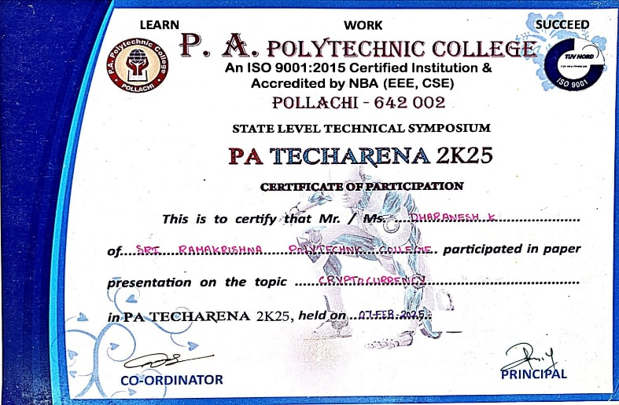 | 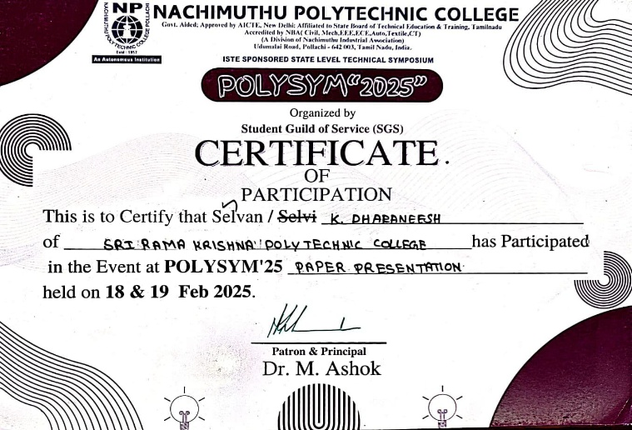
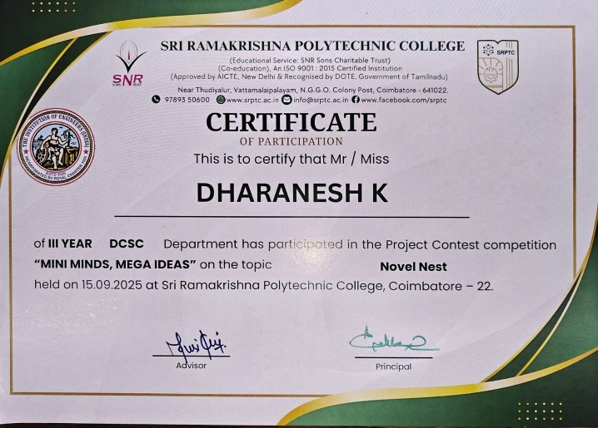 | 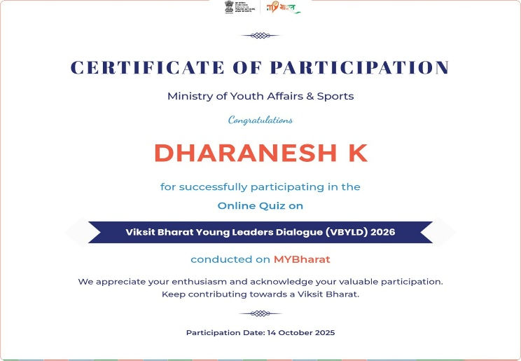

MOOCS
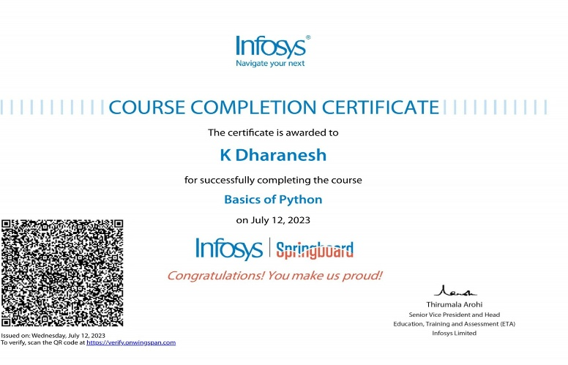 | 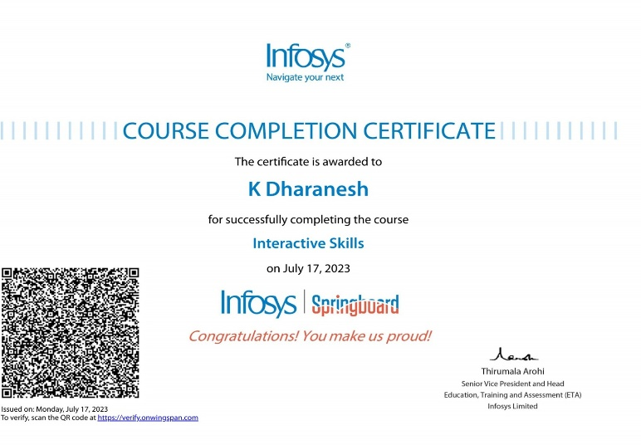
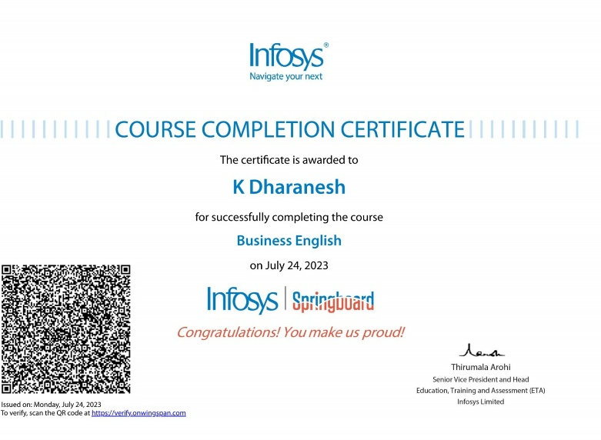 | 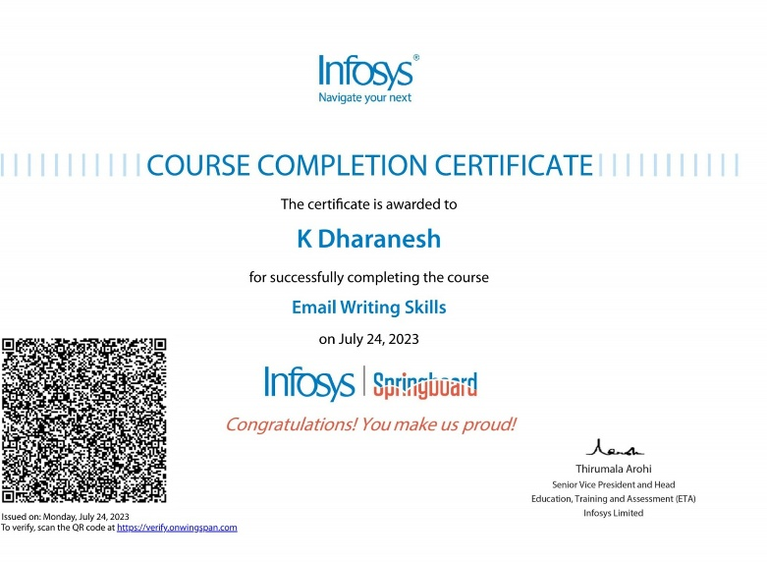
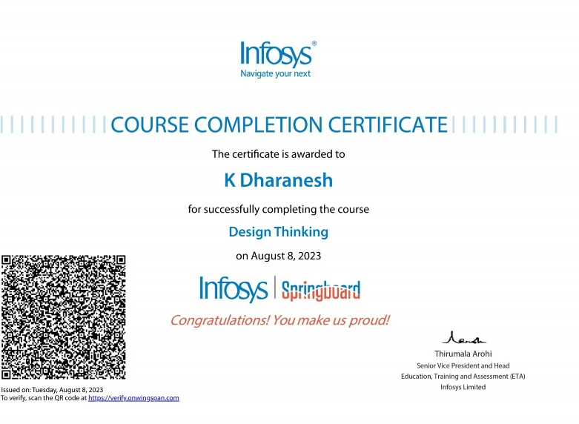 | 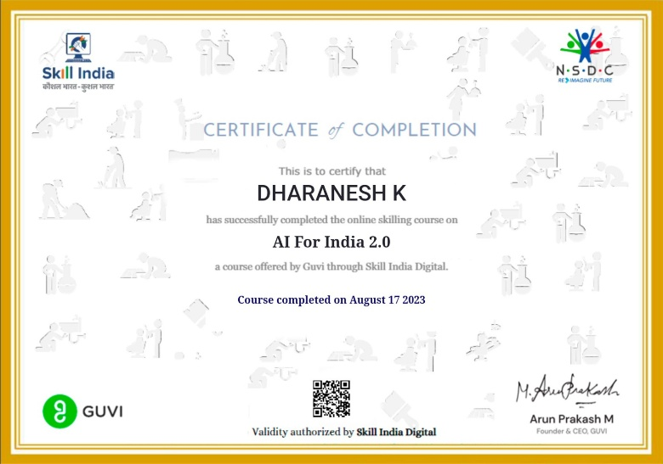
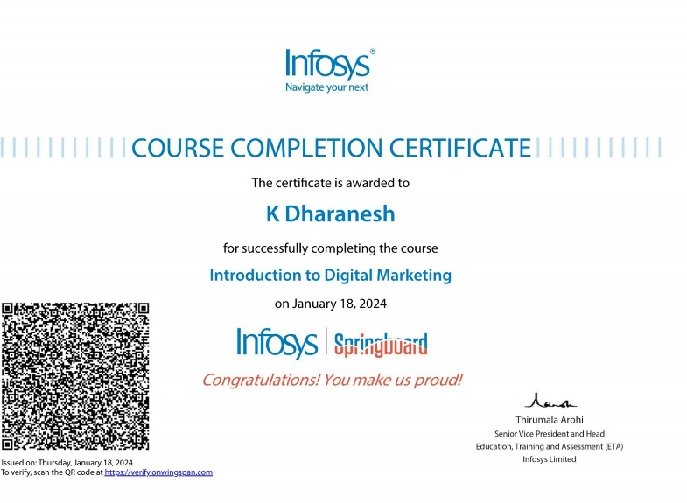 | 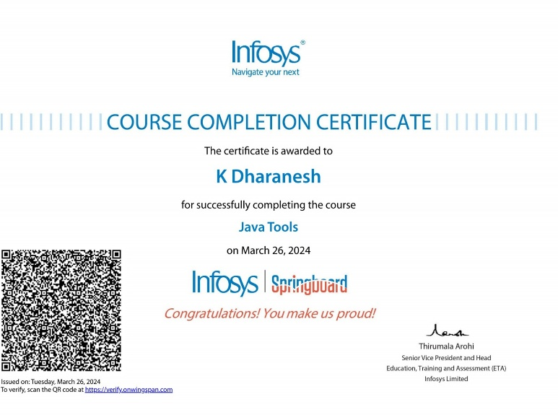
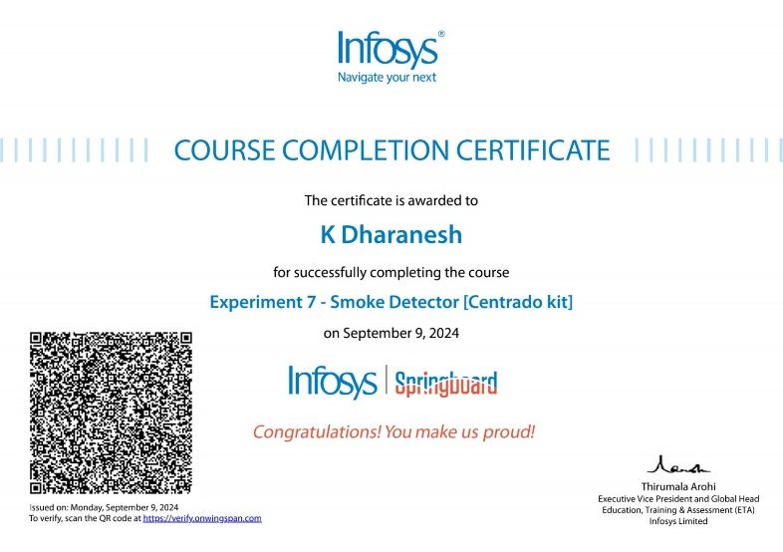 | 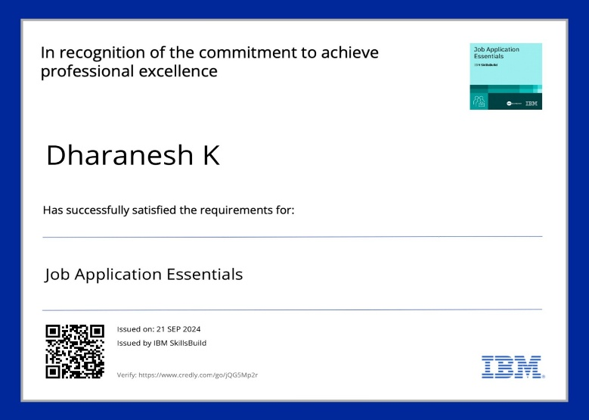
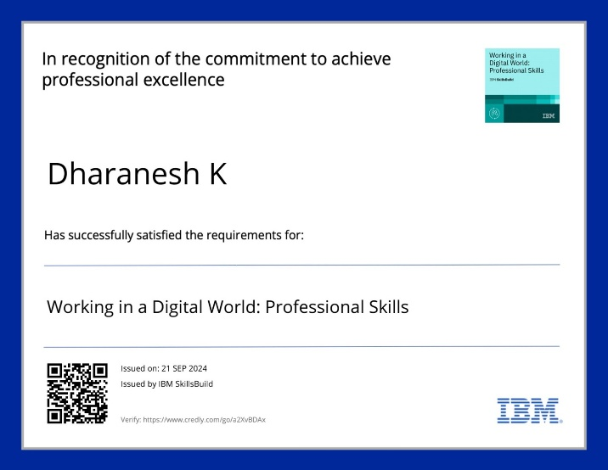 | 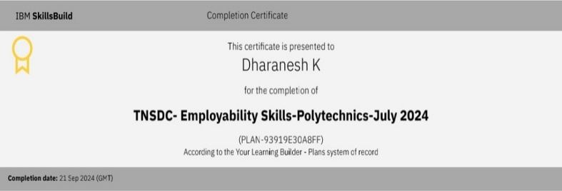
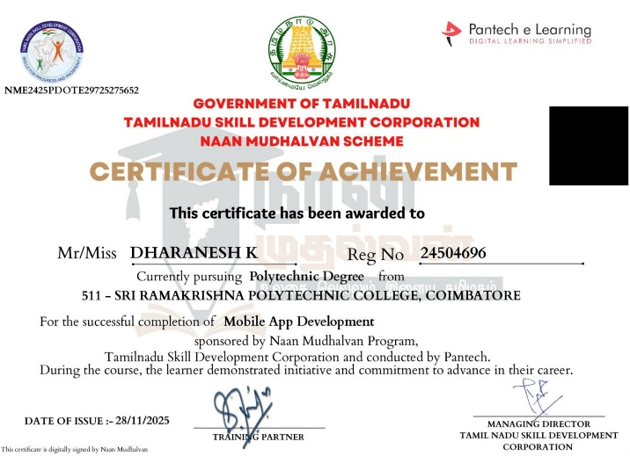 | 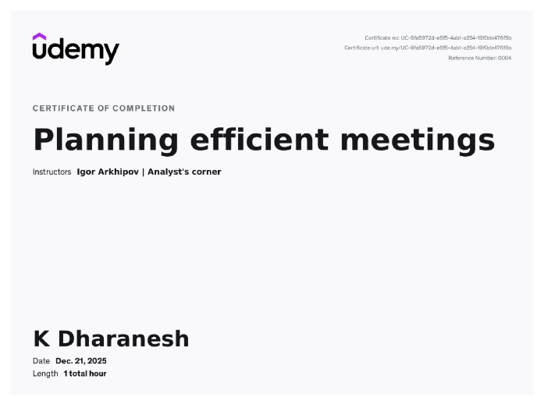
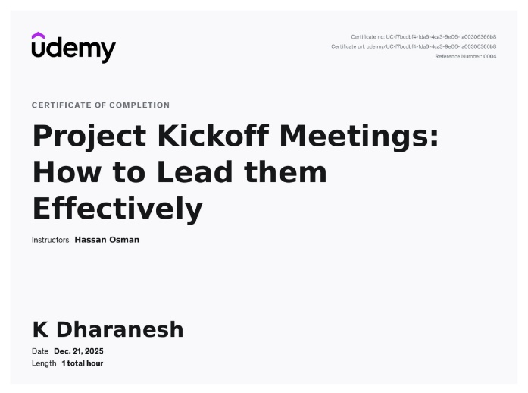 | 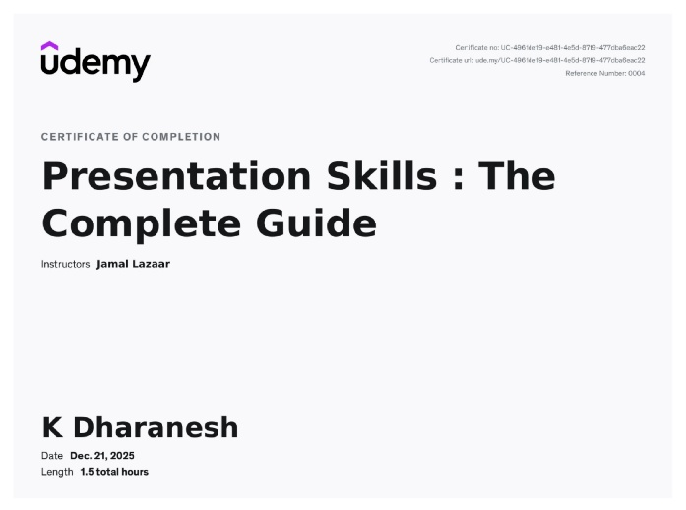
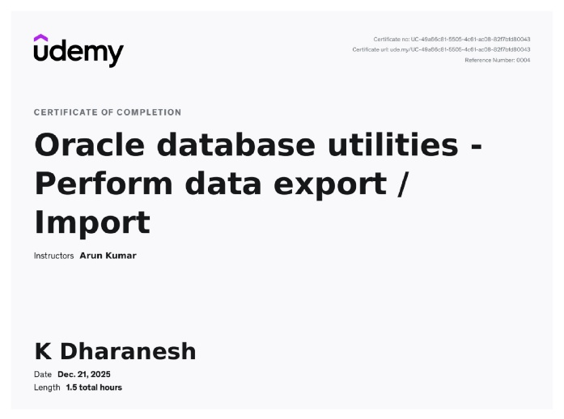 | 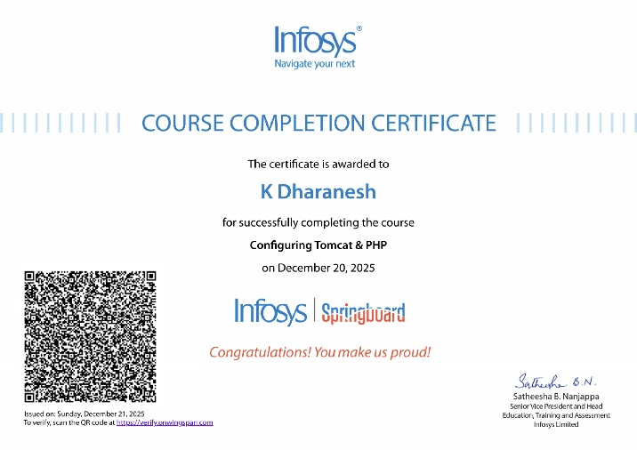
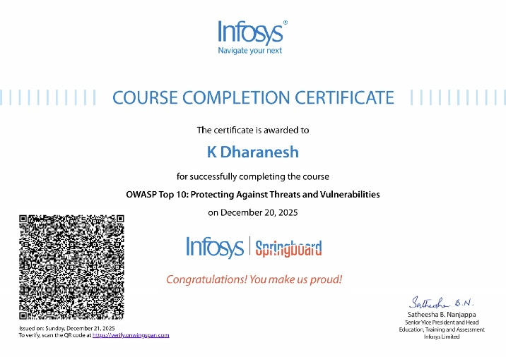 | 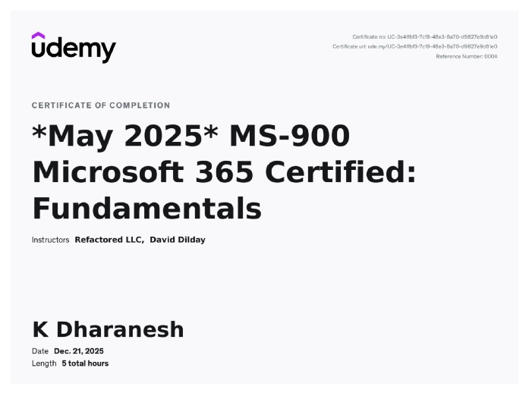
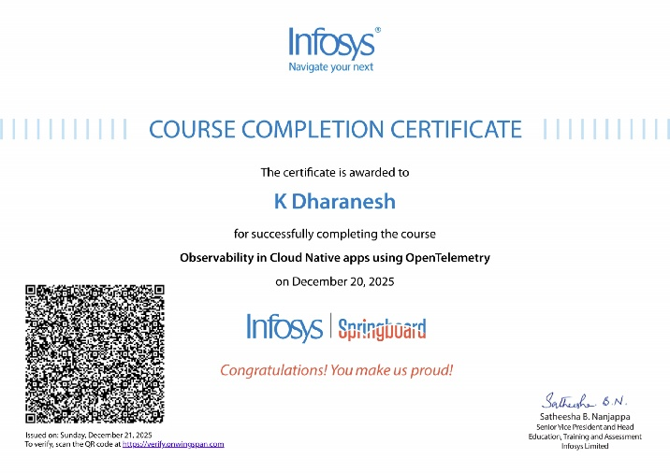 | 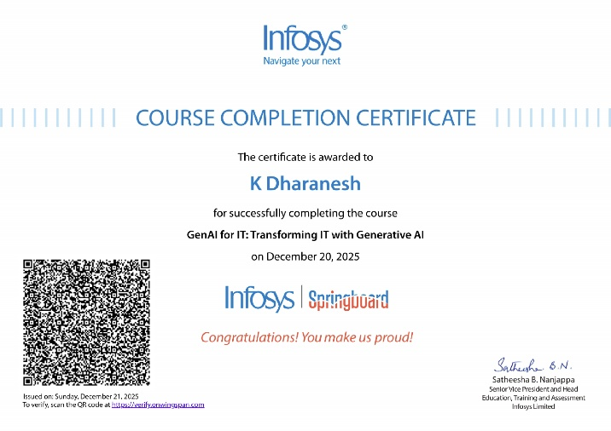
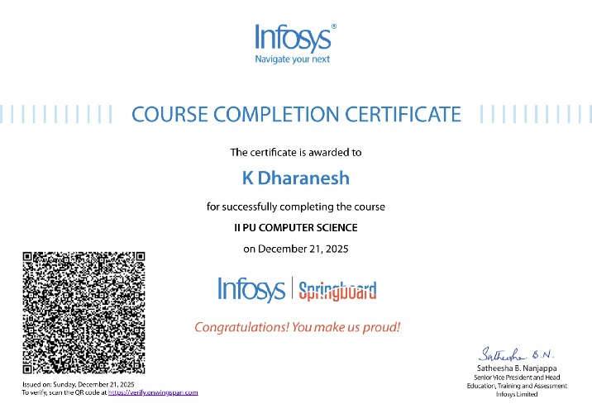 | 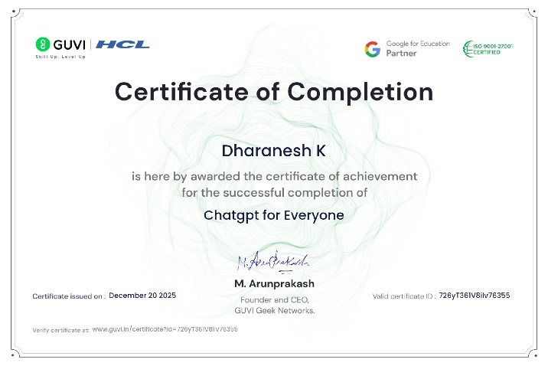
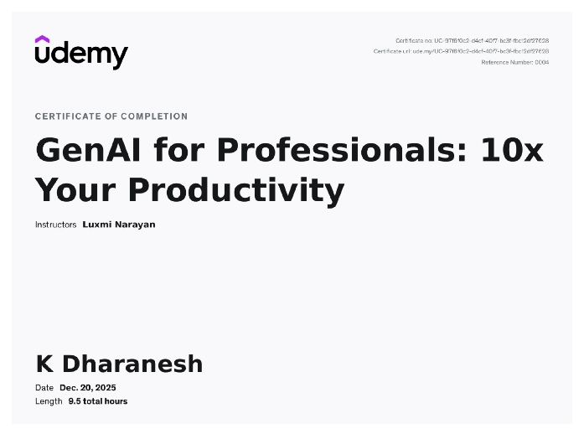 | 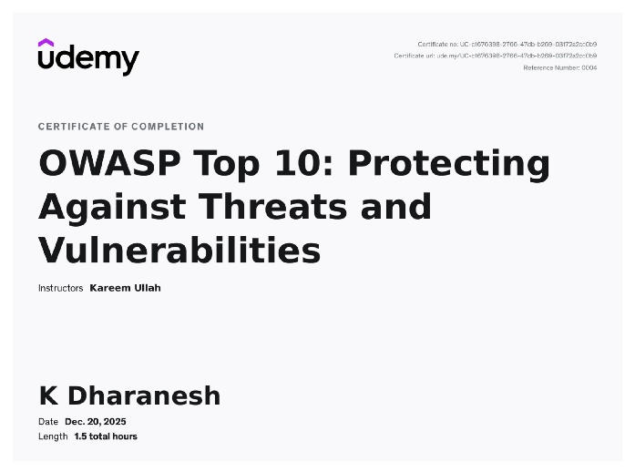
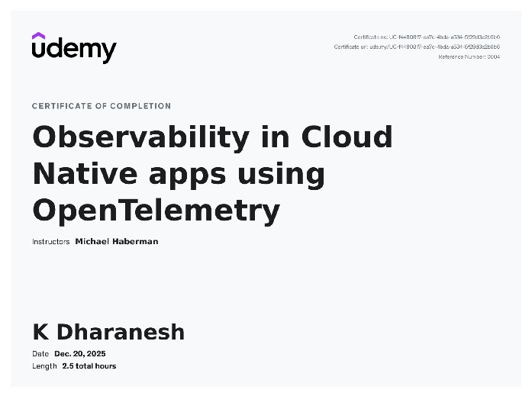 | 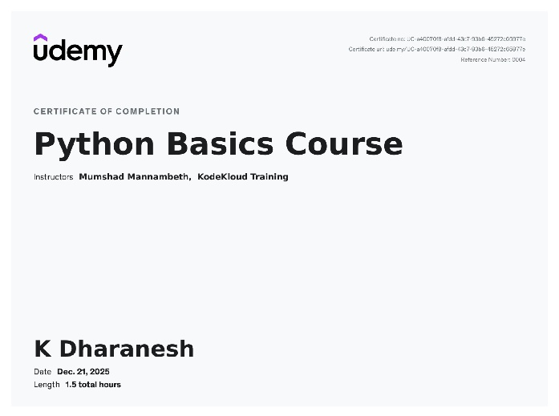
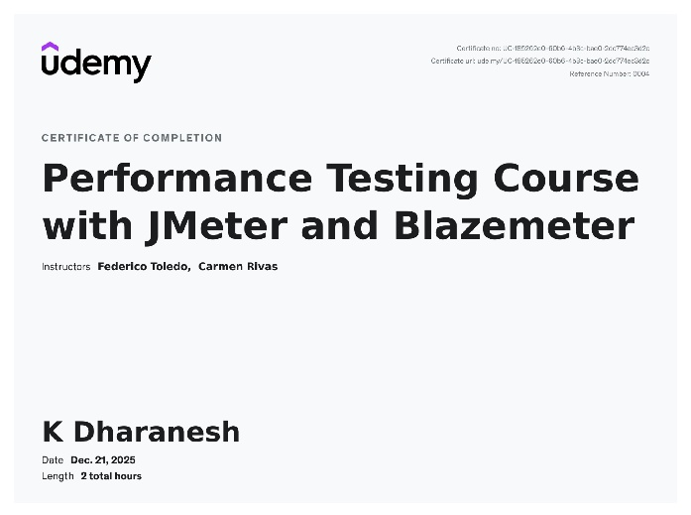

Workshop
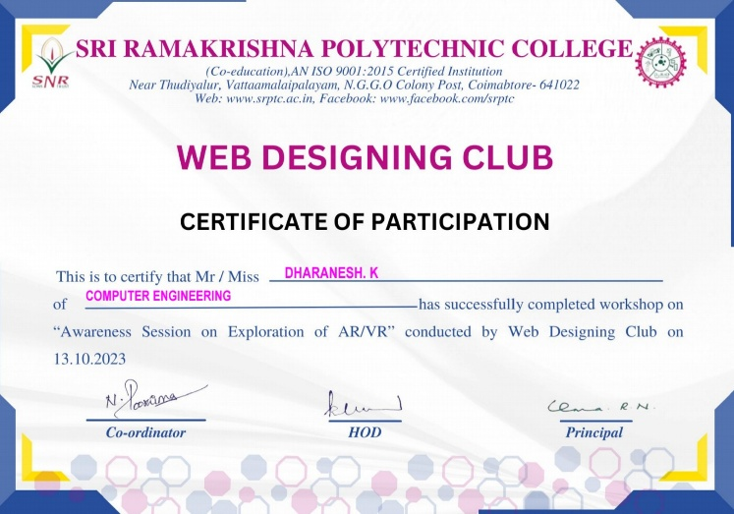 | 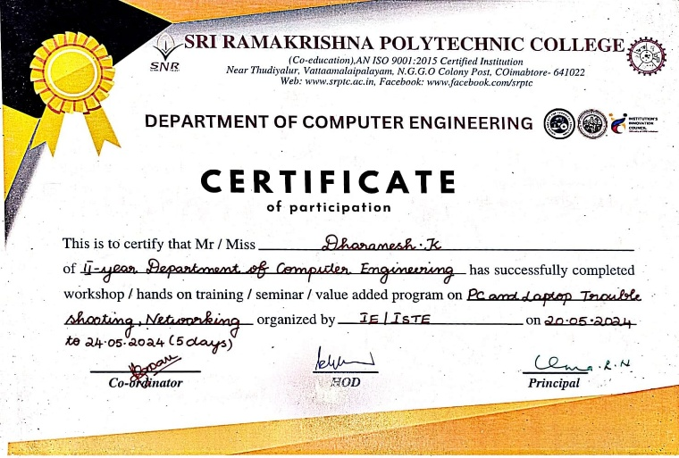

Skill development program
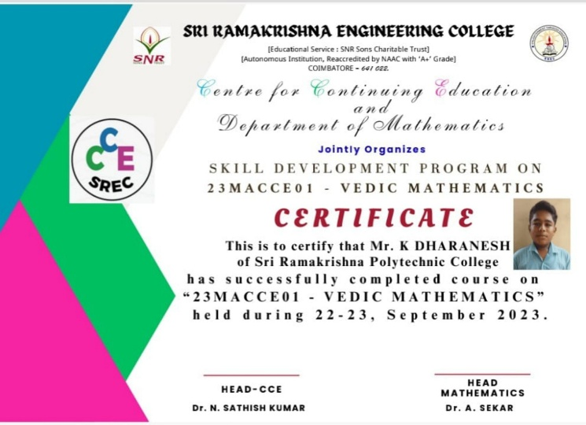

Internship
